Building Sell Watchlists

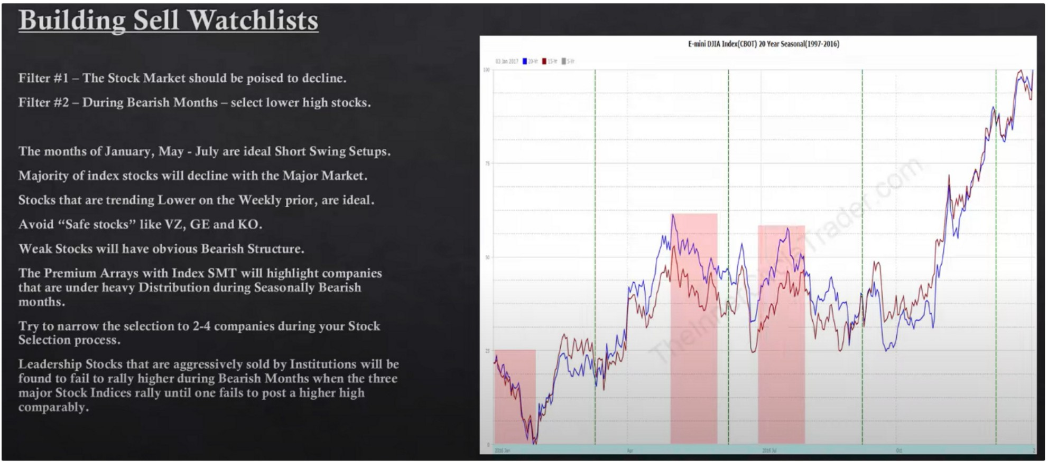



111w••-Ce-N.

1111..-

intwOowJoneslrd.lmalAYffllQt

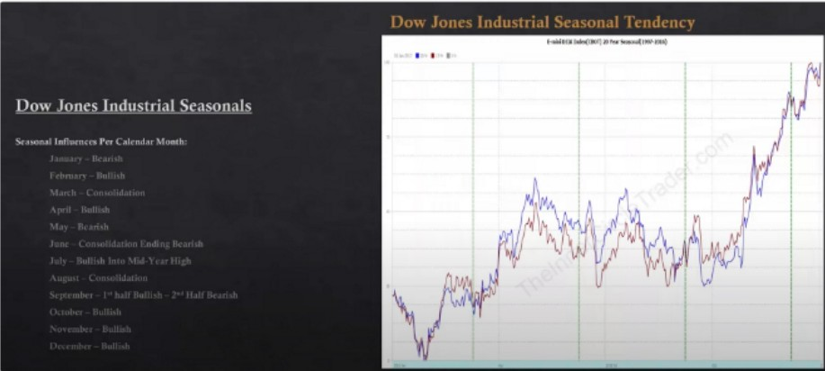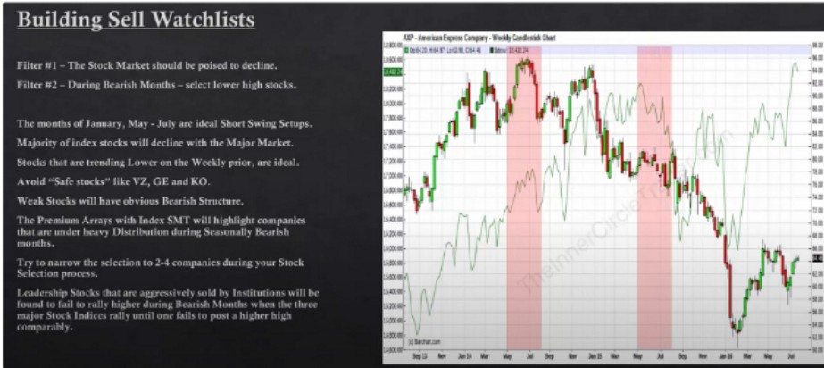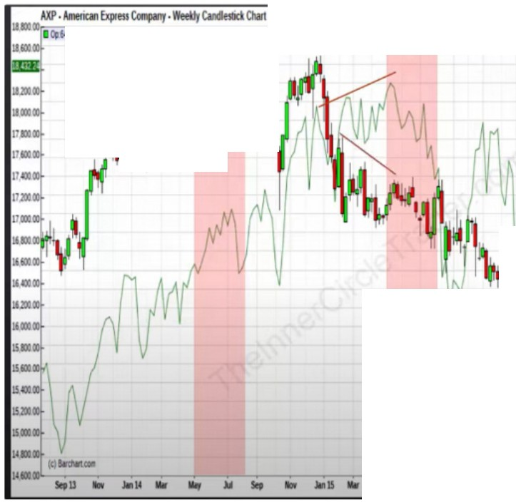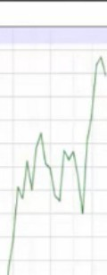

*.I*

u1 •--aaw ..

·••

·..•.•

·••

·••

...

·..•.•

·••

...

...

•141111

*'ltt*

·..•.•

...

...

·..•.•

.•

...

...

.. .. .. .. ... .. ..

..

·••

·••

..

&1t1tt11.1u-.ct,

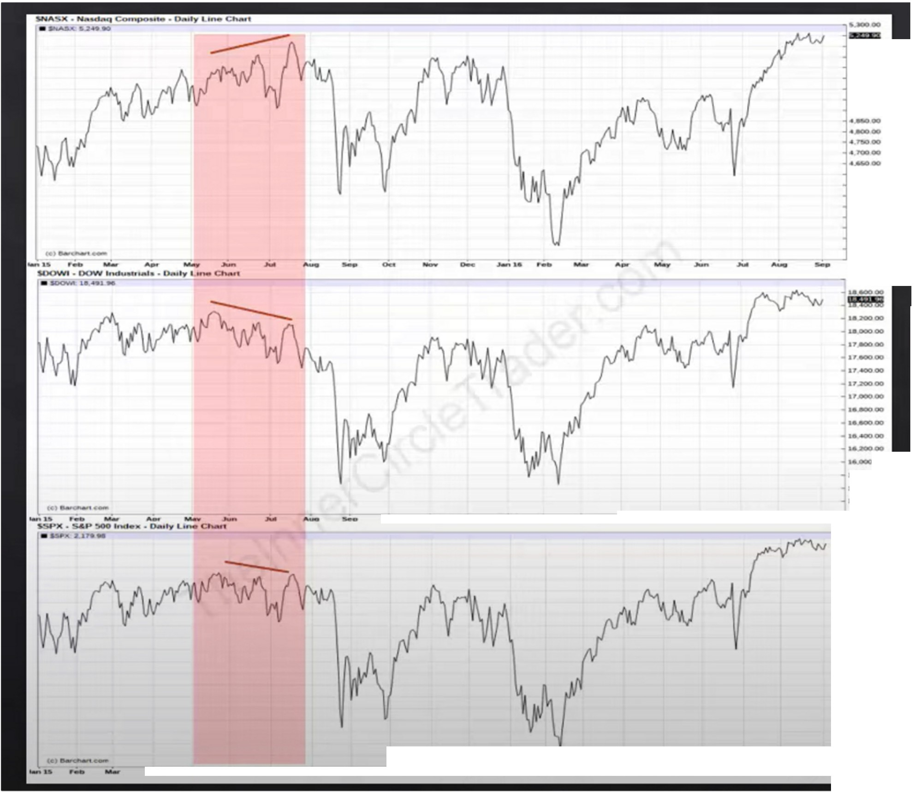

·..., ­..

·-­

.-lli#IIOOD

·.**u**.**o**-.**o**.**o**.­**o**..

......

-­

..

-

-

- -

-,• -

·--

-

,.,, ...

- -

- -

....

- -

·--

........

- - ·..-..-..

First red area didnt fit the criteria because there was no SMT with DOW and insitutional orderflow as still bullish there on the DOW

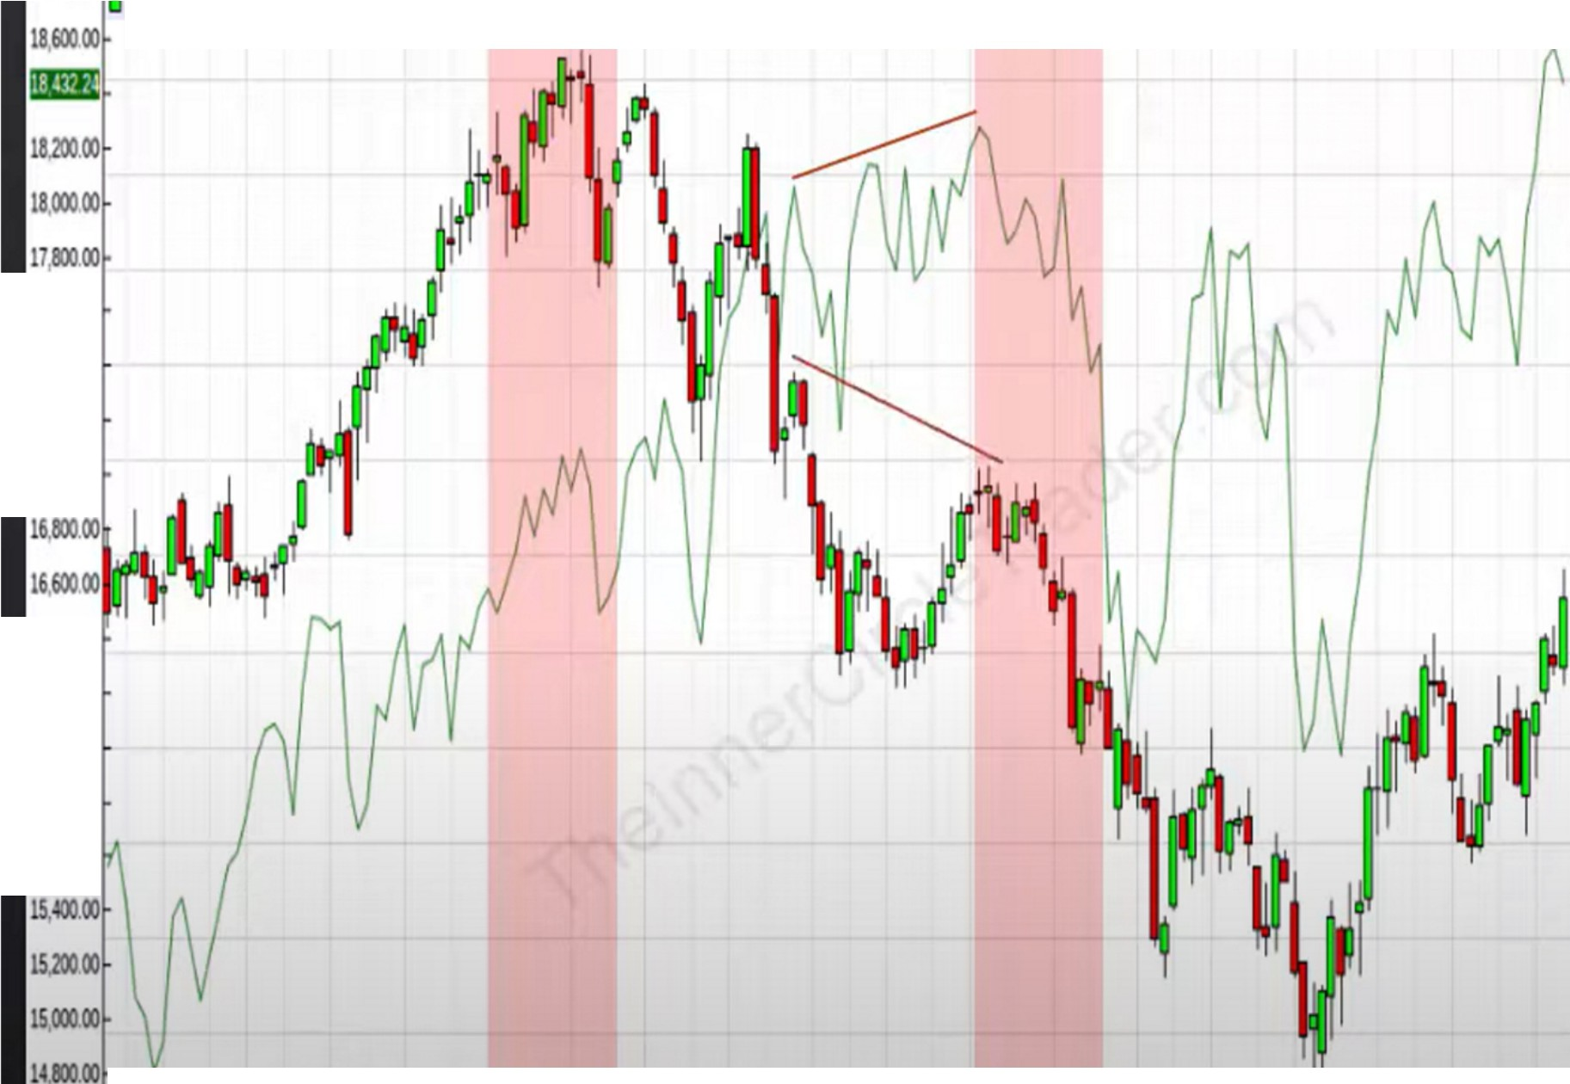

18,9:»00.

CAT·Cater llar Inc·Weekly CandlestickChart

Op'l9. 5, 29,LIJ.7831Cl82.76 1Sdo1, 1 24

llSOO

**-11000**

**-10000**

**17,600.00**

**17,40000**

**17,20000**

**17(0),00**

**-9500**

**-8500**

**1640000**

**6,200.00**

**16,tmOO**

**159:»00**

**1560000**

**-1100**

**-lSOO**

- **7000**

**-6500**

**-6000**

**(C)S.d\ln. 1460000**

**Sepll 110¥ •14**

**- -**

**11W M1Y**

**- - - -. 5600**

"

**Sep Nor •15**

**1w M1Y** "

**Sep**

**110¥** •II **1w M1Y .M**

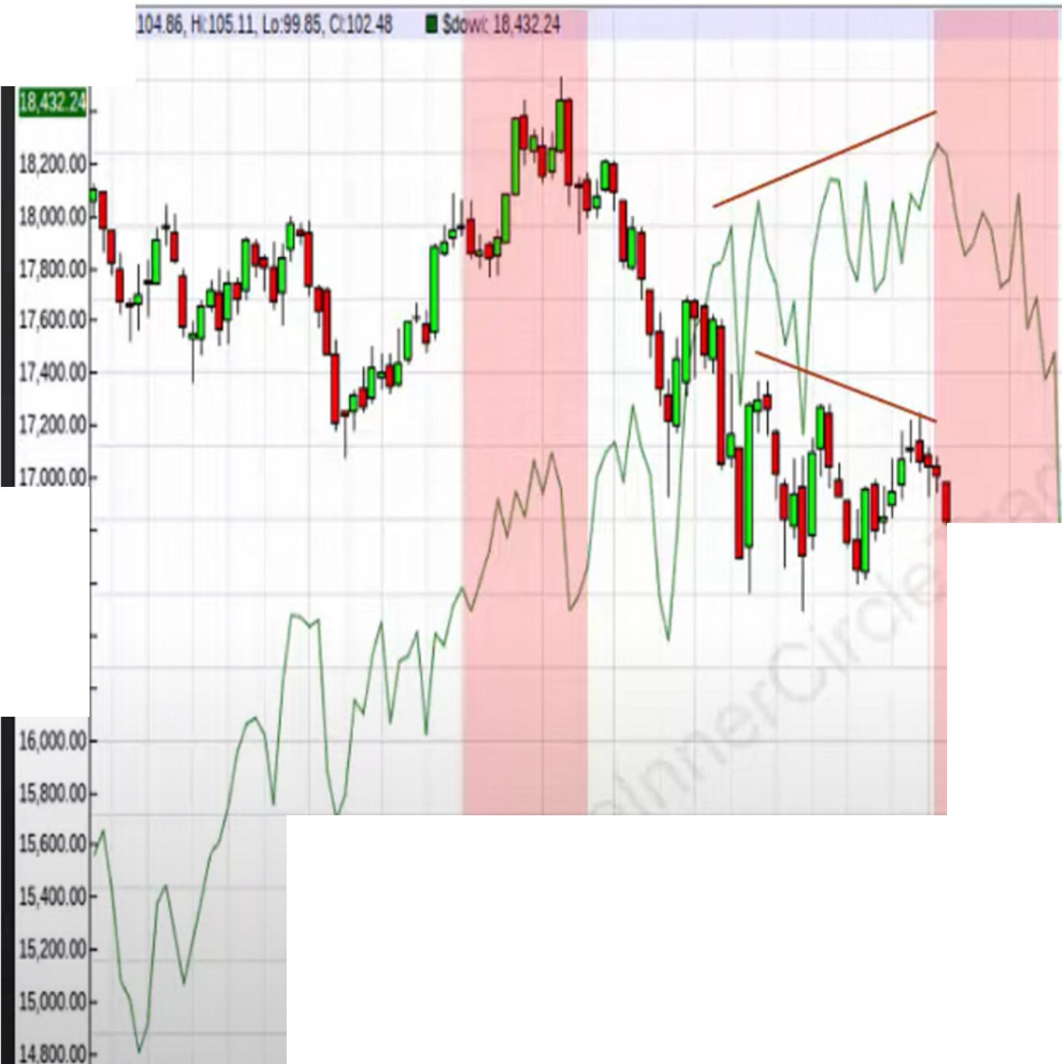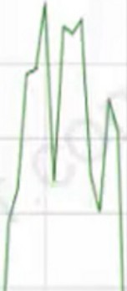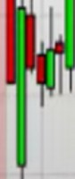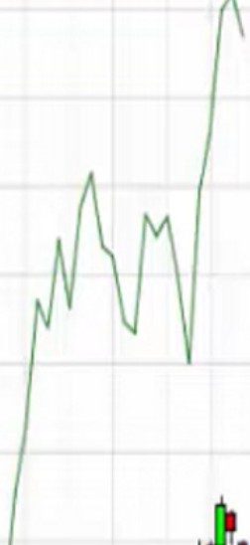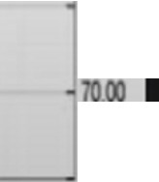

CVX •Chevron C0<p • Weekly Candlestick Chart

181m00IOp

1860000

1 00

* 13500

moo

12500

* l.10.00
* llSOO

16,lm.OO

16,60000

16(1)00

6,200.00

.

·,j

'

**.M**

-11000

-

1 00

100.00

-9500

- 00

-8500

•!000 7500

(c)S.Cll4rt.

14.60000 ---,--- ---.----.----,--- ---

Sep13 **llov ,i., 14 loW lily .M Sep llov ,i., 15 loW Miy**

**Sep llov ,i.,16 loW Illy**

**.M**

6500

Sep13 **llov .J.i14 loW lily .M Sep llov ,i.,15 loW Miy .M Sep llov ,i.,1' loW lily .M**

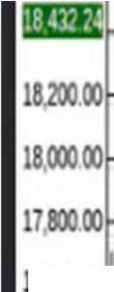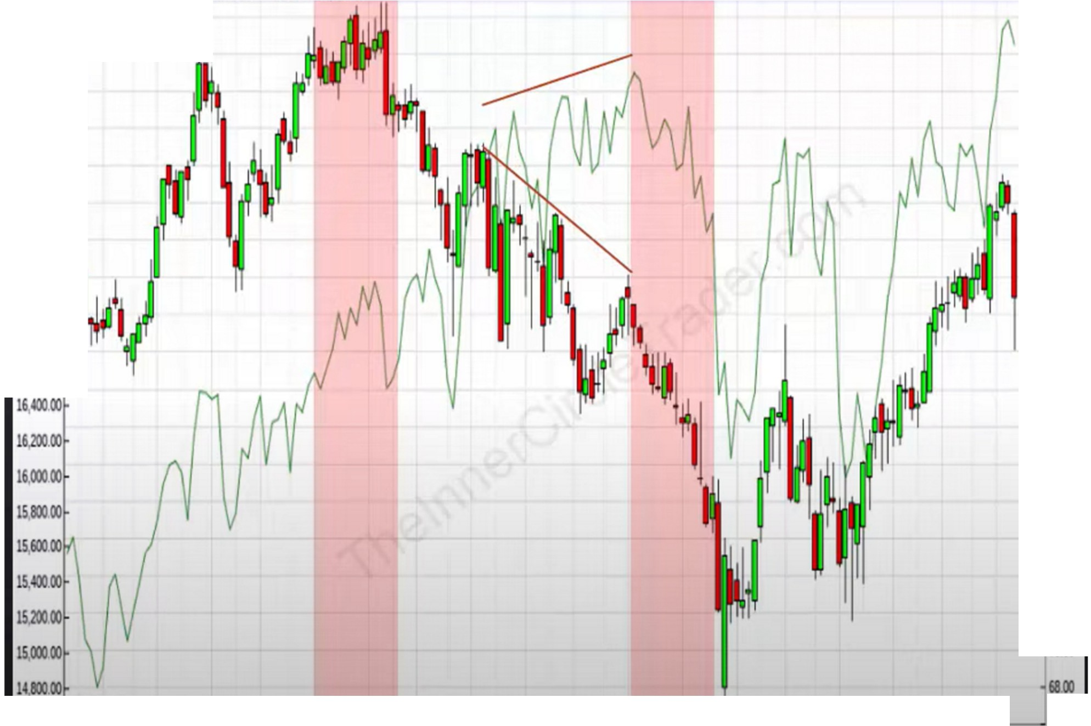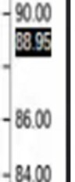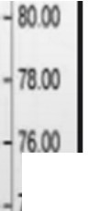

XOM, Exxon Mobil C0<p, Weekly Candlestick Chart

l&.moo ,-Op-93_7_93_628,6_12,_Cl_S8_9S_I_Soo_,-,, -8,-

1860000

l0600

lOIOO

* 10200
* 10000

9800

-9600

7,600.00'

17. 00

1720000 **'1**

1700000

161m.OO

1660000

9'00

* 92.00

·82.00

400

-n.oo

-7000

(c)e.dlan.

1460000 -.-----..------.----.----.-- -.---

-..---,---,.-----,---,----. ---.-

6600

Walmart would be thrown to the sides simply because there was a consolidation and not a real drop off

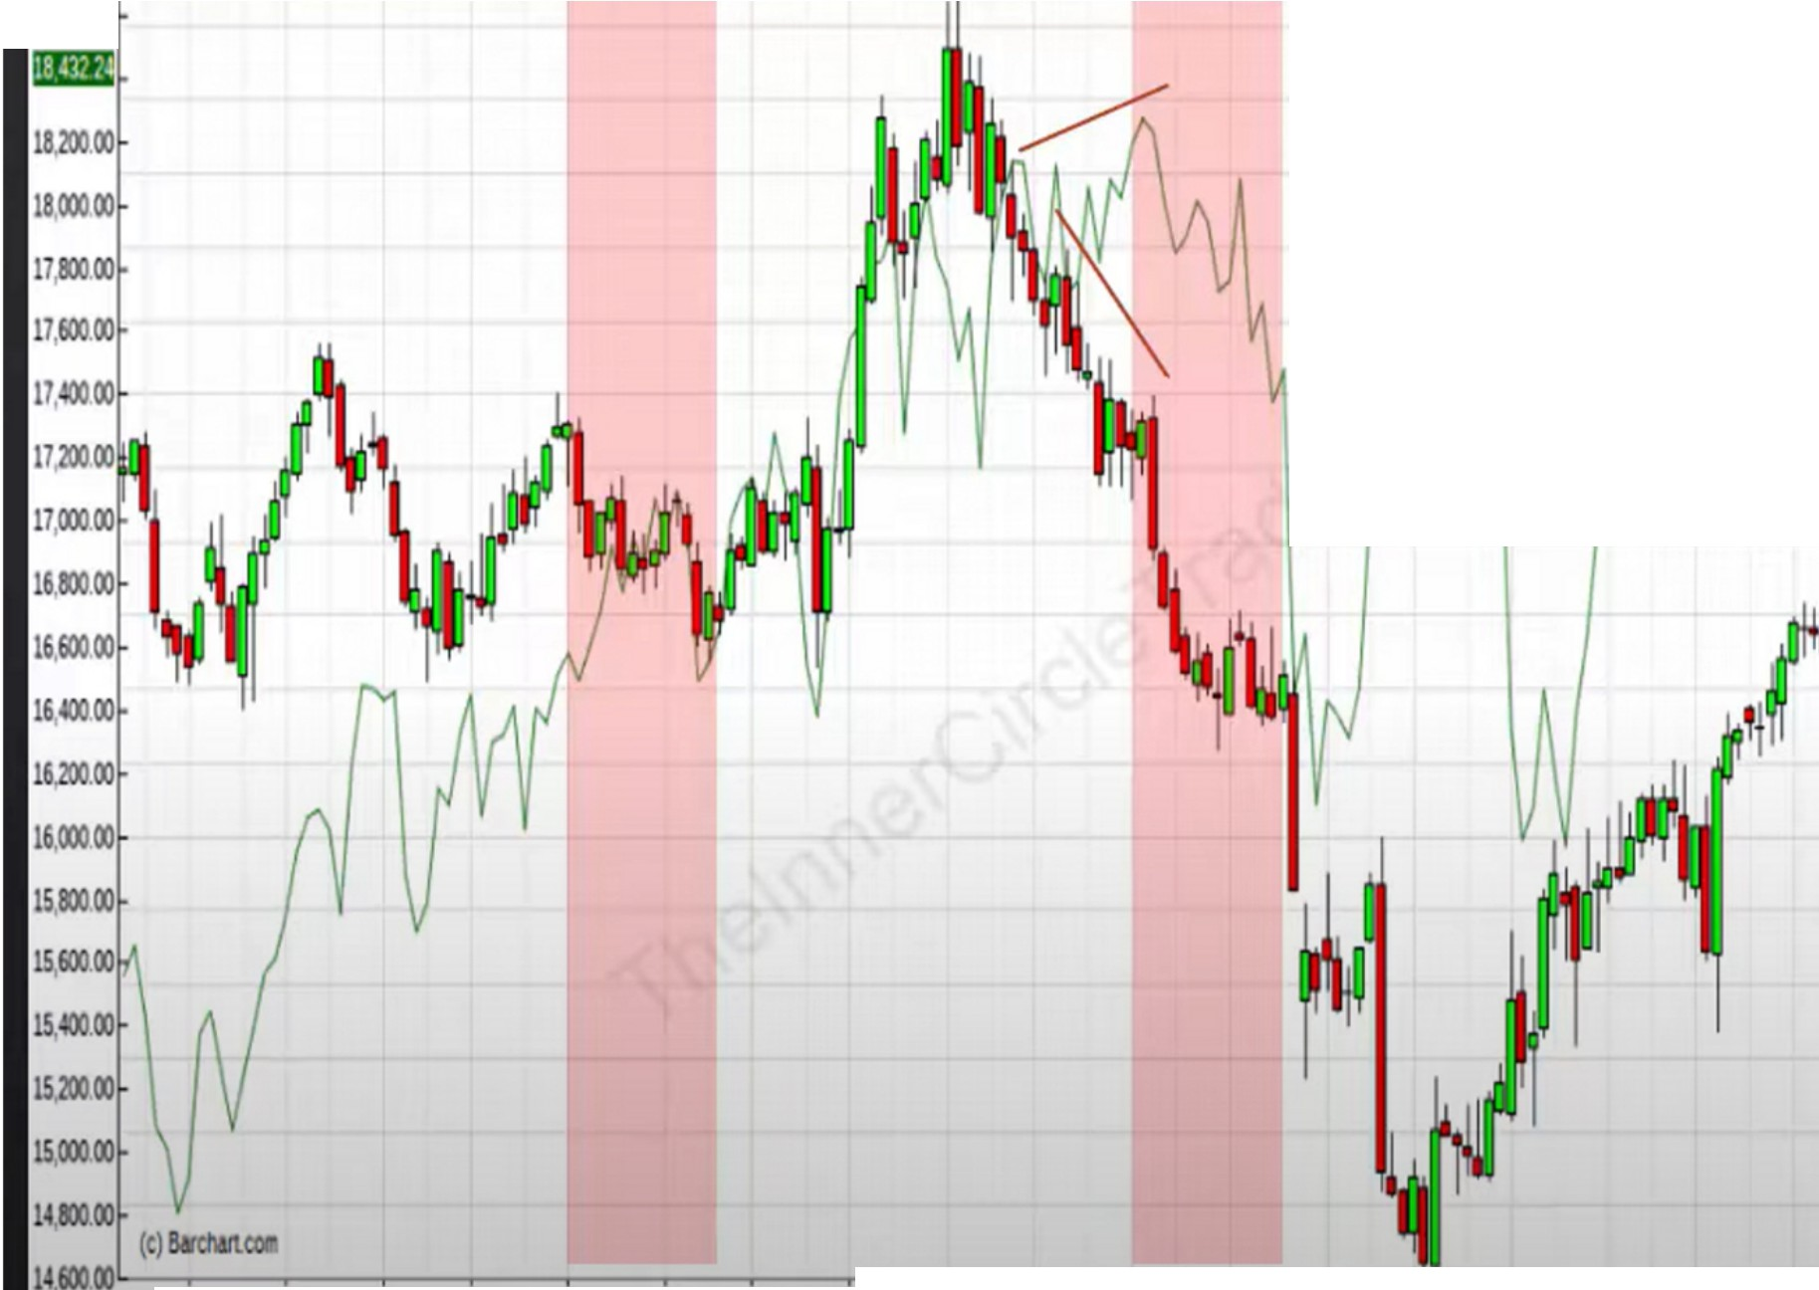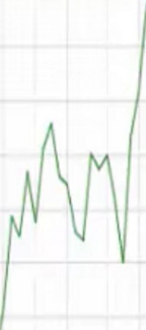

WMT , Wal-Mart Store$, Weekly CandlestickChart

IB OOIOp73.SS 7407, 72.4, 72.97 I ,1.1843:!4

1860000

92J

9000

8800

8600

84.00

**82.00**

**7800**

**600**

**7400**

iii

**72.00**

**7000**

**6800**

**6600**

**6400**

**6200**

**6000**

**5800**

**Se!l13 Nov .lir114 MIi' U., M**

**Sell**

**-.--.- -----. oo**

**Nov Jirl***IS* **MIi' Mly M Sep Nov .lir11' MIi' U., M**

It works consistenly because smart money does the same thing time and time, they have a simple rule based system theyre following and we can track that

Learn this to your children and they can have another income or build their retirement money These 4 asset class studies we did this month are important to know for the general market

You look for institutional orderflow on the weekly to be either bearish or bullish and youre lining that up with the seasonal tendencies

Arjo I Twitter, lnstagram I Linktree

Linktree. Make your link do more.

I https://t.co/HhmmTN1fUI

JavaScript is not available.

***"!I*** https://twitter.com/arjoio